TUTORIAL TO ATTEND ONLINE ANNUAL GENERAL MEETING OF
SHAREHOLDERS FOR FISCAL YEAR 2026

CONTENTS
1. Choose language 2
2. Instructions for attending and voting at the fiscal year 2026 online AGM of Coteccons Construction Joint Stock Company 2
3. Instructions for Authorization to attend the Online AGM 4
4. Supporting contact 5

- Choose language
On top right corner – Click on the white square icon.
(Note: VI = Vietnamese, EN = English)

- Instructions for attending and voting at the fiscal year 2026 online AGM of Coteccons Construction Joint Stock Company
To attend the online AGM of Shareholders and vote by electronic voting, a Shareholder or a Shareholder's authorized person can log in according to the following steps:
Step 1: Log in
Shareholders use one of the following devices: computer/tablet/smartphone or other electronic devices with internet connection and access to the address: ctd.bvote.vn à Click “Shareholders Login”


Notes: Shareholders should use one of the browsers Chrome, Firefox, Coccoc, Safari… on your computer or smartphone for the best performance.
- Enter Username (Username was provided in the invitation letter).  - Enter Password (Password was provided in the invitation letter).  - Then click “Log in”. | 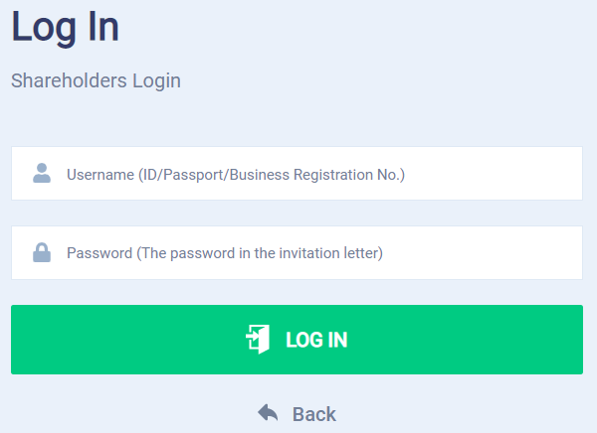
If Shareholders forget their passwords:  - Click “Forgot password?”  - Enter the OTP code which will be sent to the phone number registered by the Shareholder at the Vietnam Securities Depository (VSD)/ Coteccons.  - Then click “Login”. | 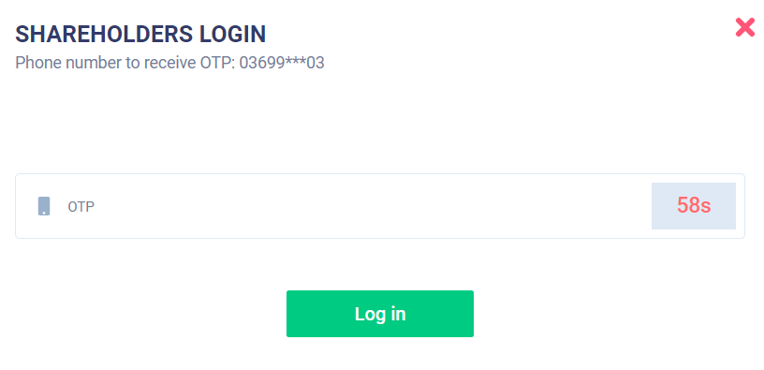
Step 2: Confirm to attend the meeting
Shareholders click "I Confirm to Attend The Meeting" to access the online meeting room.
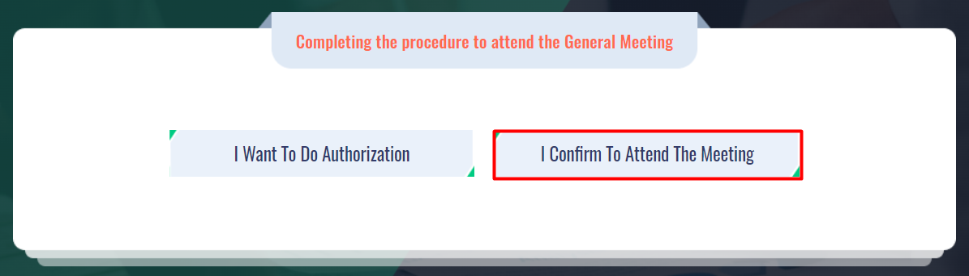

Step 3: Voting on the matters
- Shareholders choose the opinions Affirmative votes - Negative votes - Abstention for each matter.
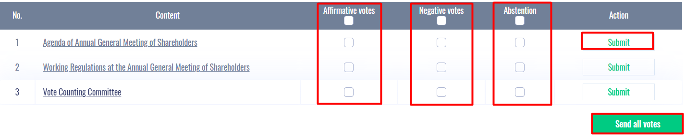
- Then click “Submit” for each matter or click “Send all votes” for the selected matters
- Shareholders cannot change the voting results after they have been successfully submitted to the system.
Step 4: Discussions in the meeting
Shareholders discuss in the AGM under the guidance of the Chairman as the following forms:
Shareholders click on the icon “Register for discussion” at the bottom right corner of the screen.
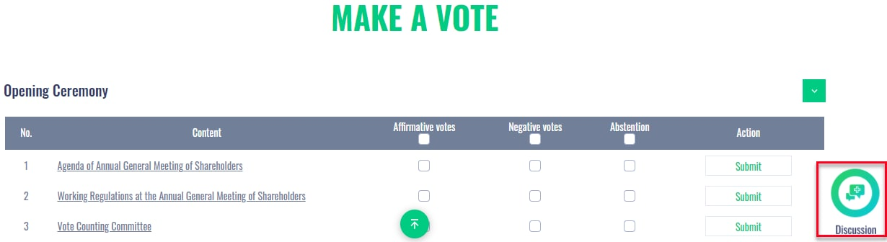
Then enter the content to register for discussion and then click “Submit”. Time to submit comments is from 08:00, 20 October 2026, until the Meeting ends the discussion part.
- Instructions for Authorization to attend the Online AGM
- In case a Shareholder wants to authorize another person to attend the Online Meeting, Shareholders can log in the system according to the instructions in Section 1 - Step 1 of this Guide, and select “I want to do authorization”.
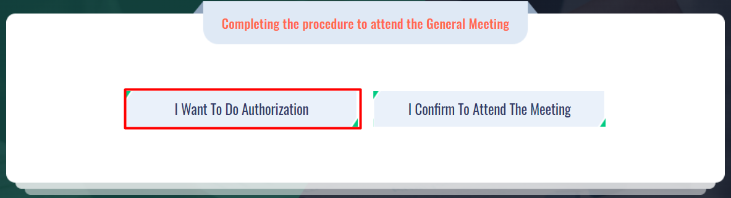
- Select the Authorization Method
- Direct authorization: Download the authorization form, fill in the information and then deliver it to the Coteccons at the following address: Investor Relations - 236/6 Dien Bien Phu, Gia Dinh Ward, Ho Chi Minh City before 5:00 p.m. on October 13th, 2026
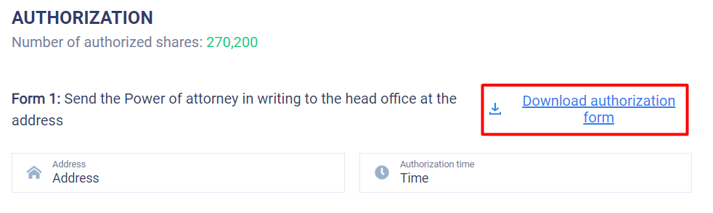
- Online authorization: Online authorization needs to be done before 5:00 p.m. on October 13th, 2026.
Shareholders can authorize online in the following 02 ways.
Method 1: Authorize all of the Shareholder's shares to the Chairman.
- Step 1: Shareholders click on the Chairman of the Board of Directors box, then click 'Continue.
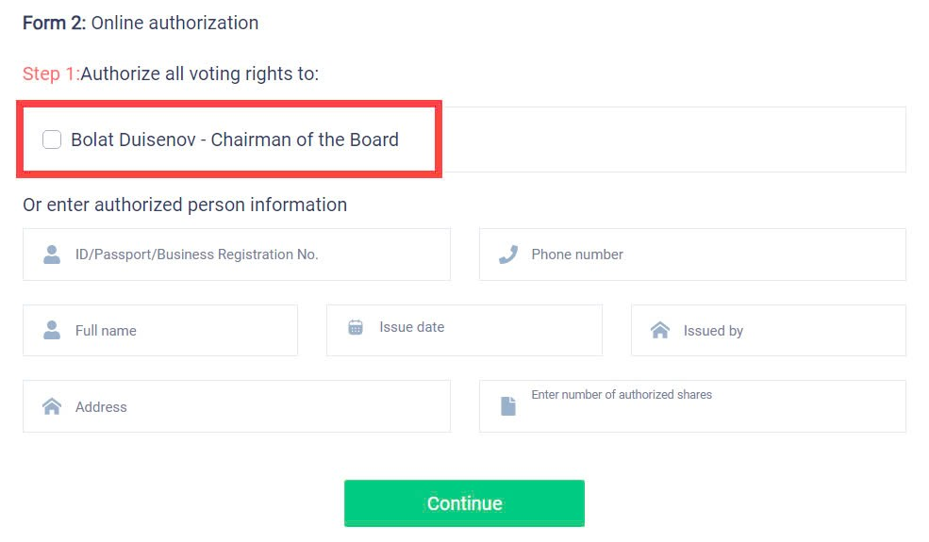
- Step 2: Shareholders click download “Power of attorney”, sign/seal to confirm the authorization.
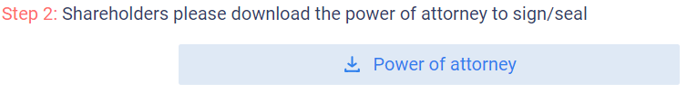
- Step 3: Shareholders upload the signed/stamped Power of Attorney and click “Authorization”.
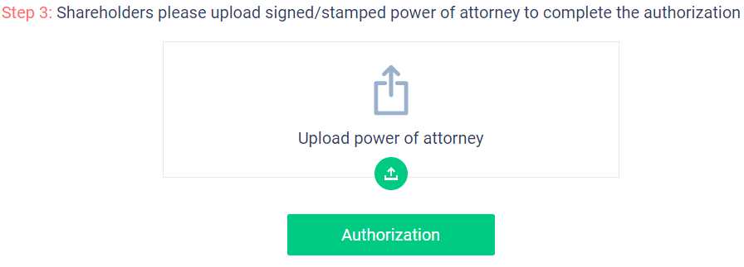
Method 2: Authorize to another representative.
- Step 1: Shareholders should fill in the authorized person's information completely in the form and then click "Continue."
Note when "Enter number of authorized shares": The number of shares authorized must be less than or equal to the number of shares owned by the Shareholder. If shares remain after authorization, the Shareholder can still authorize another representative or continue to authorize the Chairman.
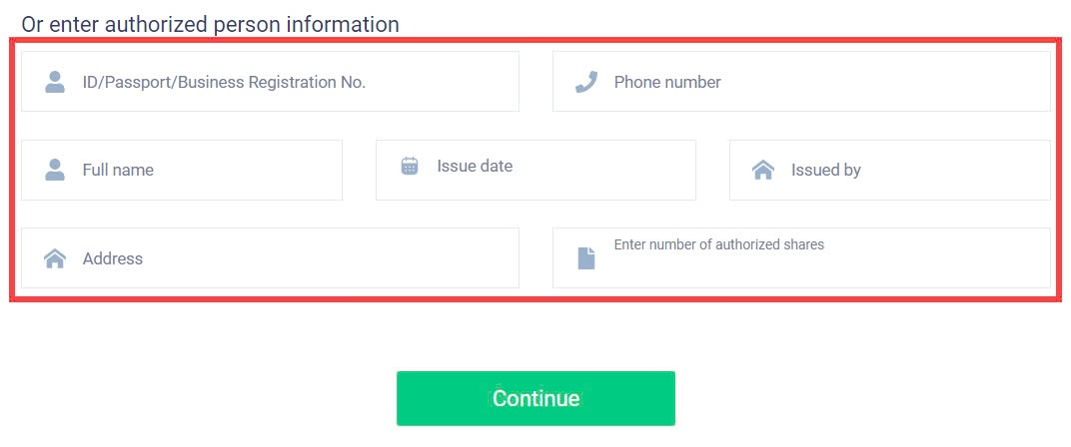
- Step 2 and 3 are the same as in Method 1.
- Supporting contact
Problems related to the process of logging in or e-voting at the fiscal year 2026 Annual General Meeting of Shareholders of Coteccons Construction Joint Stock Company, Shareholders, or an authorized person, please contact at phone number: 0889.604.668 or (028) 3514 2255/66 for support, guidance./.

